Old Testament Stories
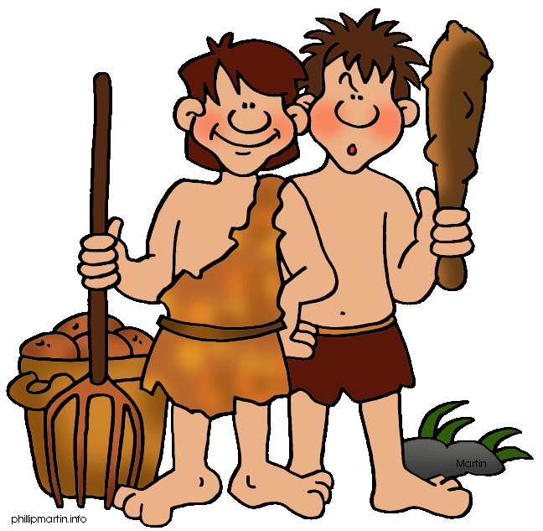

“Cain and Abel”

Genesis 4

What would you like to praise God for today?

- Pray for God’s guidance as you study

Adam made love to his wife Eve, and she became pregnant and gave birth to Cain. She said, “With the help of the Lord I have brought forth a man.” ² Later she gave birth to his brother Abel.
Now Abel kept flocks, and Cain worked the soil. ³ In the course of time Cain brought some of the fruits of the soil as an offering to the Lord. ⁴ And Abel also brought an offering—fat portions from some of the firstborn of his flock. The Lord looked with favor on Abel and his offering, ⁵ but on Cain and his offering he did not look with favor. So Cain was very angry, and his face was downcast.
⁶ Then the Lord said to Cain, “Why are you angry? Why is your face downcast? ⁷ If you do what is right, will you not be accepted? But if you do not do what is right, sin is crouching at your door; it desires to have you, but you must rule over it.”
⁸ Now Cain said to his brother Abel, “Let’s go out to the field.” While they were in the field, Cain attacked his brother Abel and killed him.
⁹ Then the Lord said to Cain, “Where is your brother Abel?”
“I don’t know,” he replied. “Am I my brother’s keeper?”
¹⁰ The Lord said, “What have you done? Listen! Your brother’s blood cries out to me from the ground. ¹¹ Now you are under a curse and driven from the ground, which opened its mouth to receive your brother’s blood from your hand.¹² When you work the ground, it will no longer yield its crops for you. You will be a restless wanderer on the earth.”
¹³ Cain said to the Lord, “My punishment is more than I can bear. ¹⁴ Today you are driving me from the land, and I will be hidden from your presence; I will be a restless wanderer on the earth, and whoever finds me will kill me.”
¹⁵ But the Lord said to him, “Not so; anyone who kills Cain will suffer vengeance seven times over.” Then the Lord put a mark on Cain so that no one who found him would kill him. ¹⁶ So Cain went out from the Lord’s presence and lived in the land of Nod, east of Eden.
¹⁷ Cain made love to his wife, and she became pregnant and gave birth to Enoch. Cain was then building a city, and he named it after his son Enoch. ¹⁸ To Enoch was born Irad, and Irad was the father of Mehujael, and Mehujael was the father of Methushael, and Methushael was the father of Lamech.
¹⁹ Lamech married two women, one named Adah and the other Zillah. ²⁰ Adah gave birth to Jabal; he was the father of those who live in tents and raise livestock. ²¹ His brother’s name was Jubal; he was the father of all who play stringed instruments and pipes. ²² Zillah also had a son, Tubal-Cain, who forged all kinds of tools out of bronze and iron. Tubal-Cain’s sister was Naamah.
²³ Lamech said to his wives,
“Adah and Zillah, listen to me;
wives of Lamech, hear my words.
I have killed a man for wounding me,
a young man for injuring me.
²⁴ If Cain is avenged seven times,
then Lamech seventy-seven times.”
²⁵ Adam made love to his wife again, and she gave birth to a son and named him Seth, saying, “God has granted me another child in place of Abel, since Cain killed him.” ²⁶ Seth also had a son, and he named him Enosh.
At that time people began to call on the name of the Lord.

- Have you ever been in a situation where you felt you needed to compete against a “favorite”? If so, what was the basis for your suspicion and how did it make you feel?

- According to Leviticus 6:14—30, God accepts both animal and grain sacrifices. Why then do you think God rejects Cain’s sacrifice? Here are some possible reasons to consider.
- Only a blood sacrifice, in place of human death, could cover sin and guilt (Lev. 5:24,25: 7:1,2,7)
- Cain had a bad attitude or lack of faith (Heb. 11:4; 1 John 2:9-11)
- Cain’s offering didn’t mean anything to him (Isa. 1:10-20)
- Cain’s offering did not embody social righteousness (Amos 5:21-24)

- What is the result of the two brothers and their offering experiences? (Gen 4:3-6)

- When God tells Cain to “do what is right” what does this tell you about Cain’s anger?

- What do you think God means when He warns Cain, “sin is crouching at your door; it desires to have you, but you must master it.”?

- In Luke 22:31 Jesus warns Peter of a similar situation. What parallels do you see between the two stories? What differences?

- In 1 Peter 5:6-8 Peter warns believers about Satan. How might Cain have benefitted from this counsel?

- In Genesis 4, Cain had a relationship with God. But he did not have the empowering of God’s Holy Spirit. How does God’s gift of Himself through Christ empower us to deal with injustice – real or imagined?
(Matt. 26:41; Rom. 12:19—21; 1 Peter 5:7)

- After the murder of Abel, why do you think God approaches Cain as he does? Why not directly accuse Cain? Why delay punishment?

10. While it is unclear that Cain ever fully repented of killing his brother, what does God offer to those who DO repent of sin? (Psalm 103:7-13;Proverbs 27:13; 1 John 1:5-9)

11. Cain’s is a story of jealousy and anger. How do you deal with the anger in your life? Write out the following verses about anger:

Proverbs 10:12 ______________________________________________________________
Proverbs 12:16 ______________________________________________________________
Proverbs 22:24 ______________________________________________________________
Proverbs 29:11 ______________________________________________________________
Ephesians 4:26 ______________________________________________________________
Which is the most relevant to you and why?

Prayer: For one another

LIFE GROUPS

A safe place to build friendships and grow spiritually.

L ♦ Learn…………………………………………..……………..………….…..…………….. applying Biblical truth for everyday living
I ♦ Invite……………………………………………………………………………...………….……..welcoming others to our fellowship
F ♦ Fellowship……………………………………………………………………….…….nurturing Christ centered caring relationships
E ♦ Evangelism…………………..……………………………………………………….…….. reaching others with the hope of Christ

DID YOU KNOW?

The story of Cain and Able is the timeless account of sibling rivalry. We’d be naïve to think this was the first time the two boys had tangled. But it certainly it was the most tragic. After Cain kills his brother, God marks Cain to offer him some protection. What this “mark” was has been the subject of speculation through the centuries.
The Hebrew word for mark (owth) is most frequently used in the Bible to mean “sign”. There is no indication that this mark was intended for anyone other than Cain. Further, all the descendants of Cain would have perished in the Flood. Any genetic aspect to “the mark of Cain” would have died out with his lineage.
Still, the mystery of Cain’s mark has persisted through the centuries. One Jewish rabbi said that God made a horn grow out of Cain. Another said that God tattooed “a letter of God’s name onto his (Cain’s) forehead.” Still another said that God tattooed the Hebrew letter ‘vav’ on Cain.
Unfortunately early Christians associated the curse of Cain with skin color. They linked their view with the phrase in Gen. 4:5 that says, “So Cain was very angry, and his face was downcast”. The suggestion was that Cain had undergone a permanent change in skin color. An Armenian branch of Christianity in the 5th or 6th century wrote: “And the Lord was wroth with Cain. . . He beat Cain’s face with hail, which blackened with coal, and thus he remained with a black face.”
Since God’s mark of Cain is accompanied by a curse, it is easy to see how a distortion of the two could lead to the justification of slavery and the African slave trade. In time, Christians would split over the issue of slavery. One denomination even taught there were two separate heavens; one for blacks and one for whites!

Fortunately all such teachings have been officially rectified. The truth of Cain’s mark is still a mystery. What IS clear is that God’s mark was to offer Cain protection from the retribution of others. The aspect important to grasp from this part of the story is that God’s mercy is deep always open for a sinner to repent and return.

